

|  |
| --- |
| ***A signed copy of this form must be submitted with every assignment.***  ***If the statement is missing your work may not be marked.*** |

**Student Declaration**

I confirm the following details:

|  |  |
| --- | --- |
| **Candidate Name:** | **KENNEDY KIMANTHI KARIUKI** |
| **Candidate ID Number:** | **2022/20646** |
| **NCC NUMBER:** | **P00195247** |
| **Qualification:** | **LEVEL 5** |
| **Unit:** | **DYNAMIC WEBSITES** |
| **Centre:** | **COMPUTER PRIDE CENTER** |
| I have read and understood both NCC Education’s *Academic Misconduct Policy* and the *Referencing and Bibliographies* document. To the best of my knowledge my work has been accurately referenced and all sources cited correctly.  I confirm that this is my own work and that I have not colluded or plagiarized any part of it. | |
| **Candidate Signature:** |  |
| **Date:** |  |

|  |
| --- |
| **TABLE OF CONTENTS**  **Statement And Confirmation………………..……………………………......1**  **Introduction……………………………………………………………………3**  **HTML……………………………………………………………………….....5**  **CSS………………………………………………………………………..........15**  **Reflection and References................................................................................46** |

**GWSC Website**

**Documentation**

**Explore the Great Outdoors**

*Discover the Ultimate Wild Swimming and Camping Experience*

**Dive into Natural Beauty**

In this digital era, we introduce you to the Global Swimming and Camping Sites Web Application. It's more than just a website; it's your passport to the untamed world of swimming and camping. We've transformed the way you experience the wild.

**Unveiling Web Applications**

Our web application is a gateway to the most magnificent swimming and camping destinations worldwide. Hosted on a remote server, it's accessible via your web browser, opening doors to unrivaled outdoor adventures.

**Your Portal to Aquatic and Camping Bliss**

Imagine a world where you can explore the planet's most breathtaking swimming spots and camping sites. Immerse yourself in crystal-clear waters, set up camp in the heart of nature, and savor the great outdoors – all from the convenience of your web browser.

**Universal Access**

Our web application is designed to adapt seamlessly across all devices. Whether you're on a computer, tablet, or smartphone, the same immersive experience is only a click away, ensuring you never miss a moment of adventure.

**Powered by HTML**

HTML, the language of the web, forms the foundation of our site. The header welcomes you with our iconic GWSC logo, the company name, and a user-friendly navigation bar. You'll also find a "Register" button, providing easy access to our registration page, where you can input your details. Select pages feature intuitive search bars to help you discover the ideal swim or camp location.

**Journey through the Wilderness**

In the heart of our web app's body, you'll find a world of information. Explore captivating swimming and camping spots with mesmerizing images and detailed descriptions. Certain pages host forms to collect user data, securely stored in our database.

**Stay Connected with Nature**

Our footer section is your source for staying informed. Subscribe to our newsletter and keep up with the latest aquatic and camping adventures. Navigational links will guide you to various sections of our web app, and vibrant social media icons connect you with fellow adventure enthusiasts.

**Your Adventure Begins Now**

Welcome to the Global Swimming and Camping Sites Web App, where every corner of the world is your playground. Our unwavering dedication to providing you with the finest aquatic and outdoor experiences is your assurance of a memorable journey. The copyright information at the page's bottom represents our commitment to your adventures.

*Join us today, and let's explore the world's beauty together.*

**HTML**

The design of the website is purely by HTML. The website has 10 interlinked pages

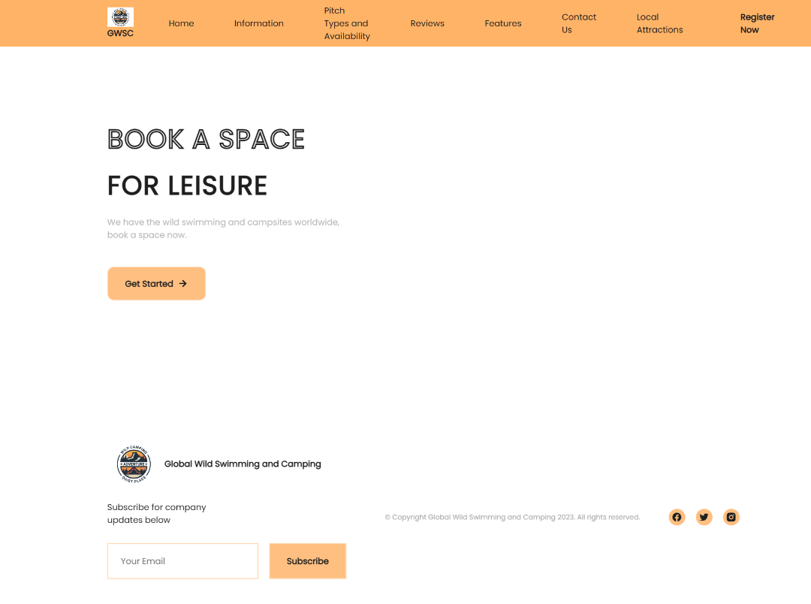

**This is my Homepage**

The User is welcomed by interesting visuals, minimal text, and a button that prompts the user to register on the website.

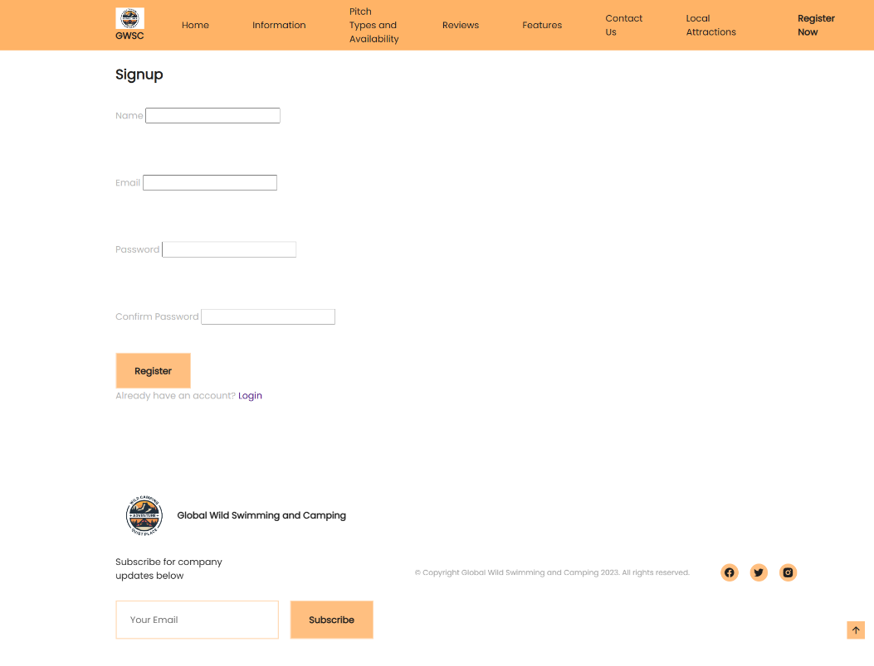

The Get Started button navigates you to the information page where the user catches a glimpse of information regarding the available swimming and campsites.

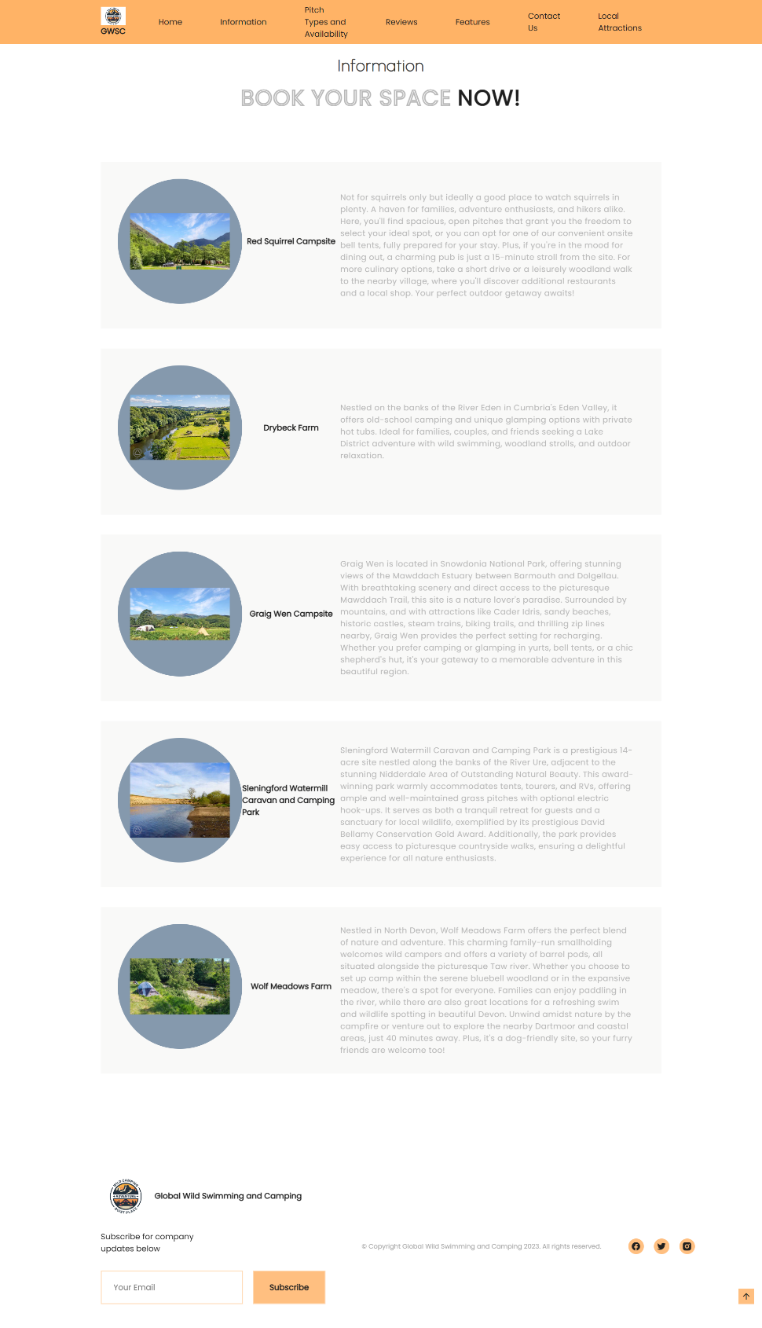



At the footer there are links to GWSC social media pages, a copyright and a subscription to the company newsletter.

Clicking on the company logo reverts you back to the home page.



The register button on top navigates to the our register page where the user may be able to register their details.

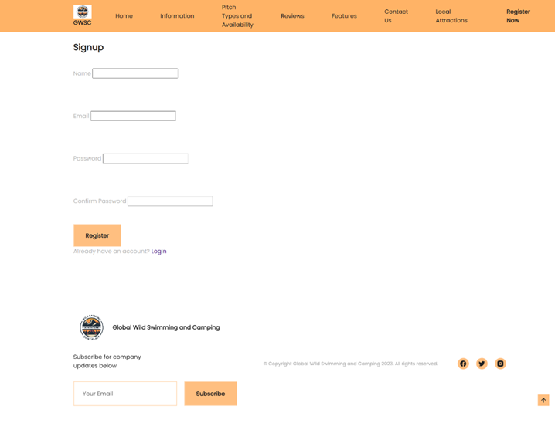

Theres also a Login button if the user already has an account, that takes you to the login page: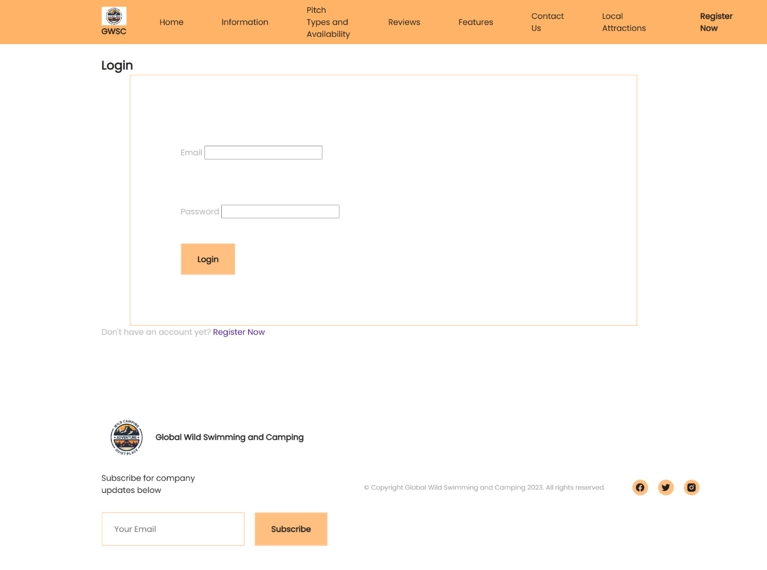

The pitches and availability button takes you to the respective page, where theres more detailed information about the campsites and their availability, theres also a booking section for users who have logged in or have an account.

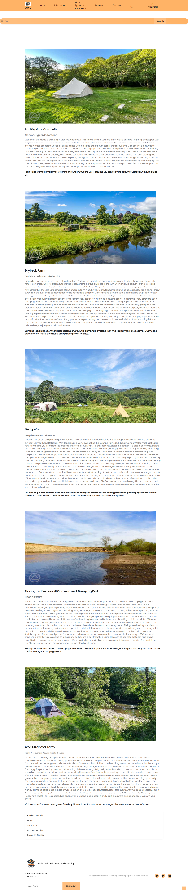

The reviews page provides information given by previous happy campers:

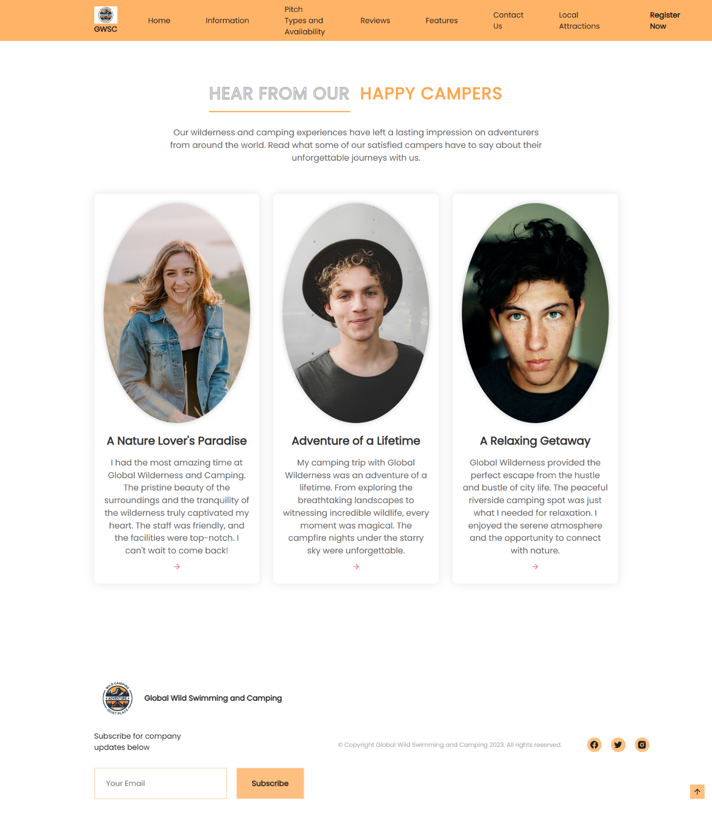And the features page takes you to a detailed page showcasing the available features and amenities present

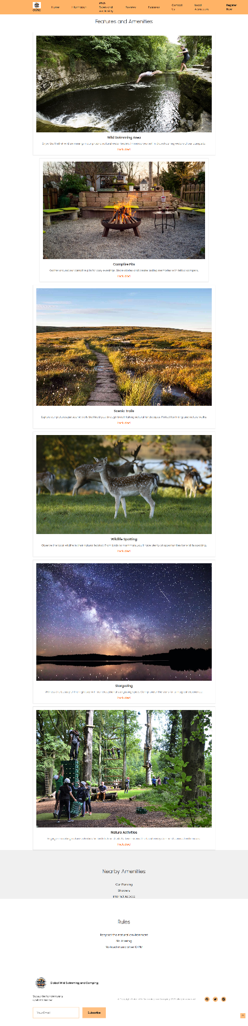

The local attractions page provides beautiful pictures for the sights one will be able to witness on their wilderness experience.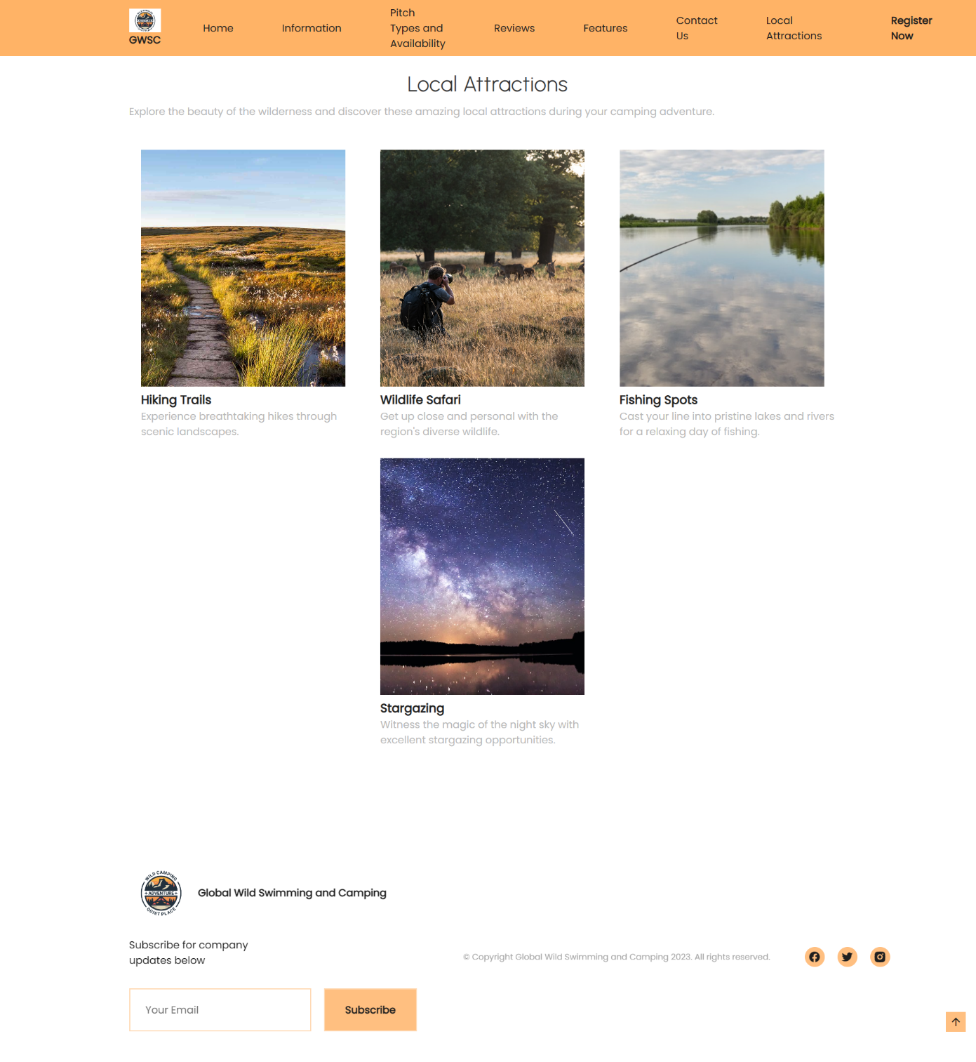

**CSS**

I used Cascaded Style Sheets to style the elements in my website.

/*---------------------FONTS-----------------*/

@import url('https://fonts.googleapis.com/css2?family=Montserrat:wght@400;500;600&family=Poppins&family=Urbanist:wght@100&display=swap');

/*-----------------------VARIABLES CSS--------------------*/

:root {

--header-height: 3.5rem;

/*----------COLORS----------*/

--first-color: hsl(30, 100%, 75%);

    /* Light Orange */

    --first-color-light: hsl(30, 100%, 85%);

    /* Lighter Orange */

    --first-color-alt: hsl(30, 100%, 70%);

    /* Slightly Darker Orange */

    --first-color-dark: hsl(30, 100%, 65%);

    /* Dark Orange */

    --first-color-gray: hsl(210, 20%, 60%);

    /* Gray */

    --title-color: hsl(0, 0%, 12%);

    /* White */

    --title-color-black: hsl(0, 0%, 12%);

    /* Black */

    --text-color: hsl(0, 0%, 72%);

    /* Light Gray */

    --text-color-light: hsl(0, 0%, 65%);

    /* Lighter Gray */

    --body-color: white;

    /* Very Dark Gray */

/*---------------FONT AND TYPOGRAPHY---------*/

--body-font: 'Poppins', sans-serif;

--second-font: 'Urbanist', cursive;

--biggest-font-size: 2rem;

--bigger-font-size: 1.5rem;

--big-font-size: 1.25rem;

--h1-font-size: 1.5rem;

--h2-font-size: 1.25rem;

--h3-font-size: 1rem;

--normal-font-size: .938rem;

--small-font-size: .813rem;

/*----------FONT WEIGHT-----------*/

--font-bold: 700;

--font-black: 900;

/*-----------Z INDEX-----------*/

--z-tooltip: 10;

--z-fixed: 100;

}

/*---------------RESPONSIVE TYPOGRAPHY---------------*/

@media screen and (min-width: 1024px) {

    :root{

        --biggest-font-size: 6rem;

        --bigger-font-size: 3.5rem;

        --big-font-size: 2.75rem;

        --h1-font-size: 2.25rem;

        --h2-font-size: 1.5rem;

        --h3-font-size: 1.25rem;

        --normal-font-size: 1rem;

        --small-font-size: .875rem;

        --smaller-font-size: .813rem;

    }

}

/*-------------BASE--------------*/

*{

    box-sizing: border-box;

    padding: 0;

    margin: 0;

}

html{

    scroll-behavior: smooth;

}

body,

button,

input{

    font-family: var(--body-font);

    font-size: var(--normal-font-size);

}

body{

    background-color: var(--body-color);

    color: var(--text-color);

}

h1,

h2,

h3{

    color: var(--title-color);

    font-weight: var(--font-bold);

}

ul{

    list-style: none;

}

a{

    text-decoration: none;

}

img{

    max-width: 100%;

    height: auto;

}

/*---------------REUSABLE CSS CLASSES----------------*/

.container{

    max-width: 1124px;

    margin-right: 1.5rem;

    margin-left: 1.5rem;

}

.section{

    padding: 4.5rem 0 2rem;

}

.section__data{

    display: flex;

    flex-direction: column;

    row-gap: 0.75rem;

    text-align: left;

    margin-bottom: 3rem;

}

.section__title,

.section__title-border{

    font-size: var(--big-font-size);

    letter-spacing: 1.5px;

}

.section__subtitle{

    font-size: var(--h2-font-size);

    font-family: var(--second-font);

    font-weight: 800;

    letter-spacing: 1.5px;

    color: var(--title-color);

    display: flex;

    justify-content: center;

    align-items: center;

}

.section__titles{

    display: flex;

    column-gap: .75rem;

    justify-content: center;

}

.section__title-border{

    -webkit-text-stroke: 1px var(--text-color);

    color: transparent;

}

.grid{

    display: grid;

    gap: 1.5rem;

}

.main{

    overflow: hidden; /*for animation scroll reveal*/

}

.color-red{

    color: hsl(0, 80%, 64%);

}

.color-green{

    color: var(--first-color);

}

/*------------------HEADER AND NAV------------------*/

.header{

    width: 100%;

    background-color: hsl(30, 100%, 70%);

    position: fixed;

    top: 0;

    left: 0;

    z-index: var(--z-fixed);

    transition: background .3s;

}

.nav{

    height: var(--header-height);

    display: flex;

    justify-content: space-between;

    align-items: center;

}

.nav .container {

    display: flex;

    justify-content: center;

    align-items: start;

}

.nav__menu {

    display: flex;

    justify-content: center;

    align-items: start;

    margin: 60px;

}

.nav__logo,

.nav__toggle{

    color: var(--title-color);

    display: grid;

}

.nav__logo{

    align-items: center;

    column-gap: .5rem;

    font-weight: var(--font-bold);

    margin-top: 12px;

    margin-bottom: 12px;

}

.nav__logo img{

    width: 100px;

}

.nav__toggle{

    font-size: 1.25rem;

    cursor: pointer;

}

@media screen and (max-width: 1023px){

    .nav__menu{

        position: fixed;

        background-color: hsla(180, 12%, 8%, .8);

        backdrop-filter: blur(32px);

        -webkit-backdrop-filter: blur(32px);

        top: 0;

        right: -100%;

        width: 100%;

        height: 100%;

        border-left: 2px solid var(--first-color-gray);

        transition: right .3s;

    }

}

.nav__list{

    padding: 5rem 0 0 3rem;

    display: flex;

    flex-direction: column;

    row-gap: 2.5rem;

}

.nav__link{

    color: var(--title-color);

    transition: color .3s;

    display: flex;

    justify-content: center;

    align-items: start;

    margin: 6px;

}

.nav__link:hover{

    color: var(--first-color-light);

}

.nav__close{

    position: absolute;

    top: 1rem;

    right: 1.5rem;

    font-size: 1.5rem;

    color: var(--title-color);

    cursor: pointer;

}

.nav .nav__button{

    background-color: hsl(30, 100%, 70%);

    border: none;

}

/*SHOW MENU*/

.show-menu{

    right: 0;

}

/*CHANGE BACKGROUND HEADER*/

.bg-header{

    background-color: var(--body-color);

    box-shadow: 0 4px 8px hsla(180, 12%, 4%, .3);

}

/*ACTIVE LINK*/

.active-link{

    color: var(--first-color);

}

/*--------------------------------HOME----------------------------*/

.home{

    position: relative;

    padding-bottom: 0;

}

.home__container{

    padding-top: 4rem;

    row-gap: 3rem;

}

.home__data{

    text-align: center;

}

.home__subtitle{

    font-size: var(--bigger-font-size);

    -webkit-text-stroke: 1px var(--title-color);

    color: transparent;

}

.home__title{

    font-size: var(--biggest-font-size);

    font-weight: var(--font-black);

    margin: .5rem 0;

}

.home__subtitle,

.home__title{

    letter-spacing: 1.5px;

    font-size: 50px;

}

.home__description{

    margin-bottom: 2.5rem;

}

/*--------------------------------SLIDESHOW----------------------------*/

.slideshow-body {

    margin: 0;

    padding: 0;

}

.slideshow-container {

    position: relative;

    width: 750px;

    height: 500px;

    margin: 0 auto;

    overflow: hidden;

}

.slide {

    position: absolute;

    width: 100%;

    height: 100%;

    object-fit: cover;

    opacity: 0;

    animation: slideshow 20s infinite linear;

}

@keyframes slideshow {

    0%,

    100% {

        opacity: 0;

    }

    10%,

    90% {

        opacity: 1;

    }

    100% {

        opacity: 0;

    }

}

.slide:nth-child(1) {

    animation-delay: 0s;

}

.slide:nth-child(2) {

    animation-delay: 4s;

}

.slide:nth-child(3) {

    animation-delay: 8s;

}

.slide:nth-child(4) {

    animation-delay: 12s;

}

.slide:nth-child(5) {

    animation-delay: 16s;

}

.home__triangle{

    height: 325px;

    position: absolute;

    right: 0;

    bottom: 0;

    clip-path: polygon(100% 0, 0 100%, 100% 100%);

}

.home__triangle-1{

    width: 105px;

    background-color: var(--first-color);

}

.home__triangle-2{

    width: 205px;

    background-color: var(--first-color-alt);

}

.home__triangle-3{

    width: 305px;

    background-color: var(--first-color-dark);

}

.home__img{

    display: flex;

    position: relative;

    z-index: 1;

    width: 250px;

    margin-top: 6px;

    margin-bottom: 96px;

    margin-left: 96px;

    margin-right: 96px;}

/*------------------BUTTON---------------------*/

.button{

    display: inline-block;

    background-color: var(--first-color);

    padding: 18px 32px;

    border: 2px solid var(--first-color-light);

    color: var(--title-color-black);

    font-weight: var(--font-bold);

    cursor: pointer;

    transition: background .3s;

}

.button:hover{

    background-color: var(--first-color-alt);

}

.button i{

    font-size: 1.25rem;

    transition: transform .3s;

}

.button__flex{

    display: inline-flex;

    align-items: center;

    justify-content: center;

    column-gap: .5rem;

    border-radius: 12px;

}

.button__flex:hover i{

    transform: translateX(.25rem);

}

/*-----------------------SPONSORS-------------------*/

.logos__container{

    grid-template-columns: repeat(2, 1fr);

    gap: 2rem;

    justify-items: center;

}

.logos__img{

    width: 120px;

    height: 120px;

}

/*--------------------PROGRAM---------------------*/

.program__container{

    justify-content: center;

    row-gap: 2rem;

    display: flex;

    flex-direction: column;

}

.program__card{

    display: flex;

    flex-direction: row;

    background-color: hsla(79, 6%, 64%, .07);

    padding: 2.5rem 3rem;

    border: 2px solid transparent;

    transition: background .5s, border .4s;

}

.program__img{

    width: 200px;

}

.program__shape{

    width: 250px;

    height: 250px;

    background-color: var(--first-color-gray);

    border-radius: 50%;

    display: grid;

    place-items: center;

    margin-bottom: 1rem;

    transition: background .5s;

}

.program__title{

    display: grid;

    justify-content: center;

    align-items: center;

    flex: 1;

    font-size: var(--normal-font-size);

    margin-bottom: 1rem;

}

.program__description{

    display: flex;

    justify-content: center;

    align-items: center;

    flex: 3;

    font-size: var(--small-font-size);

    letter-spacing: .5px;

    line-height: 150%;

}

.program__title,

.program__description{

    transition: color .5s;

}

.program__button{

    justify-self: flex-end;

    margin-top: 1.5rem;

    font-size: 1.25rem;

    color: var(--title-color-black);

    opacity: 0;

    transition: opacity .4s;

}

.program__button i{

    display: block;

    transition: transform .3s;

}

.program__button:hover i{

    transform: translateX(.25rem);

}

.program__card:hover{

    background-color: var(--first-color);

    border: 2px solid var(--first-color-light);

}

.program__card:hover .program__shape{

    background-color: var(--first-color-light);

}

.program__card:hover .program__title,

.program__card:hover .program__description{

    color: var(--title-color-black);

}

.program__card:hover .program__button{

    opacity: 1;

}

/* Search Bar styles */

.search-container {

    background: linear-gradient(45deg, var(--first-color), var(--first-color-alt));

    border-radius: 25px;

    box-shadow: 0 2px 5px rgba(0, 0, 0, 0.2);

    display: flex;

    overflow: hidden;

    margin-top: 150px;

}

#search-input {

    border: none;

    padding: 10px;

    width: 80%;

    outline: none;

    transition: all 0.3s ease;

    background: none;

    color: var(--title-color);

}

#search-button {

    background-color: var(--first-color);

    color: var(--title-color);

    border: none;

    padding: 10px 20px;

    cursor: pointer;

    transition: all 0.3s ease;

}

#search-button:hover {

    background-color: var(--first-color-alt);

}

/* Expand the input field on focus */

#search-input:focus {

    width: 100%;

}

/* Add a search icon (optional) */

.search-container::before {

    content: "\f002";

    /* Unicode for a search icon (you can use a different icon) */

    font-family: FontAwesome;

    padding: 10px;

    color: var(--title-color);

    font-size: 16px;

    transition: all 0.3s ease;

}

/* Animate the search icon on input focus */

#search-input:focus+.search-button::before {

    transform: scale(1.2);

    color: var(--first-color);

}

/* Content section styles */

.content section {

    border-radius: 10px;

    box-shadow: 0 2px 4px rgba(0, 0, 0, 0.1);

    padding: 20px;

    margin-top: 20px;

    position: relative;

    background-color: #f5f5f5;

}

.content-text {

    flex: 1;

    padding-right: 20px;

}

.content__img {

    width: 1068px;

    height: 600px;

    margin-top: 96px;

    margin-bottom: 24px;

}

.content-heading {

    font-size: 24px;

    font-weight: bold;

    margin-bottom: 10px;

    color: hsl(0, 0%, 12%);

}

.content-subheading {

    font-size: 18px;

    font-weight: bold;

    margin-top: 15px;

    color: gray;

}

.content-description {

    font-size: 16px;

    margin-bottom: 20px;

    line-height: 1.5;

    margin-top: 12px;

    color: gray;

}

.content-description b {

    display: block;

    font-weight: bold;

    margin-top: 20px;

    color: hsl(0, 0%, 12%);

}

/* Sidebar styles */

.sidebar {

    display: block;

    flex: 0 0 250px;

    background-color: #fff;

    border-radius: 10px;

    box-shadow: 0 2px 4px rgba(0, 0, 0, 0.1);

    padding: 20px;

}

.sidebar-heading {

    font-size: 20px;

    font-weight: bold;

    margin-bottom: 10px;

    color: #333;

}

.sidebar-subheading {

    font-size: 16px;

    font-weight: bold;

    margin-top: 15px;

    color: #666;

}

/* Features Section Styles */

.features {

    background-color: #fff;

    padding: 40px 0;

    text-align: center;

}

.section__subtitle {

    font-size: 24px;

    color: #333;

}

.feature-cards {

    display: flex;

    flex-wrap: wrap;

    justify-content: center;

    gap: 20px;

    margin-top: 20px;

}

.feature-card {

    background-color: #fff;

    border: 1px solid #ddd;

    box-shadow: 0 2px 4px rgba(0, 0, 0, 0.1);

    padding: 20px;

    text-align: center;

    transition: transform 0.3s, box-shadow 0.3s;

}

.feature-card:hover {

    transform: translateY(-5px);

    box-shadow: 0 4px 8px rgba(0, 0, 0, 0.2);

}

.feature-image {

    max-width: 100%;

    height: auto;

}

.feature-title {

    font-size: 20px;

    color: #333;

    margin-top: 10px;

}

.feature-description {

    font-size: 16px;

    color: #777;

    margin-top: 10px;

}

.feature-price {

    font-size: 18px;

    color: #ff6600;

    margin-top: 10px;

}

/* Nearby Amenities Section Styles */

.nearby-amenities {

    background-color: #f0f0f0;

    padding: 40px 0;

    text-align: center;

}

.amenities-list {

    list-style: none;

}

.amenities-list li {

    font-size: 18px;

    color: #333;

    margin: 10px 0;

}

/* Rules Section Styles */

.rules {

    background-color: #fff;

    padding: 40px 0;

    text-align: center;

}

.rules-list {

    list-style: none;

}

.rules-list li {

    font-size: 18px;

    color: #333;

    margin: 10px 0;

}

/*-------------------PRODUCTS--------------------*/

.col-3{

    flex-basis: 30%;

    min-width: 250px;

    margin-bottom: 30px;

}

.col-3 img{

    height: 370px;

    width: 320px;

    object-fit: cover;

}

.row{

    display: flex;

    align-items: center;

    flex-wrap: wrap;

    justify-content: space-around;

}

.col-3:hover{

    transform: translateY(-8px);

    cursor: pointer;

}

.search__form{

    float: right;

}

/*--------------------REVIEWS----------------------=*/

/* Reviews Section */

.reviews section {

    background-color: #f5f5f5;

    padding: 80px 0;

    position: relative;

    padding-bottom: 0;

}

.reviews .container {

    text-align: center;

}

.reviews .section__data {

    margin-bottom: 30px;

}

.reviews .section__subtitle {

    font-size: 24px;

    color: white;}

.reviews .section__titles {

    margin-top: 20px;

}

.reviews .section__title-border {

    font-size: 36px;

    color: white;

    border-bottom: 3px solid hsl(30, 100%, 65%);

    display: inline-block;

    padding-bottom: 10px;

    margin-right: 10px;

}

.reviews .section__title {

    font-size: 36px;

    color: hsl(30, 100%, 65%);

    display: inline-block;

}

.reviews p {

    font-size: 18px;

    color: #666;

    margin-bottom: 40px;

    max-width: 800px;

    margin: 0 auto;

}

/* Review Cards */

.reviews__container {

    display: grid;

    grid-template-columns: repeat(auto-fit, minmax(300px, 1fr));

    gap: 30px;

    justify-content: center;

    margin-top: 40px;

}

.reviews__card {

    background-color: #fff;

    padding: 20px;

    border-radius: 10px;

    box-shadow: 0 0 20px rgba(0, 0, 0, 0.1);

    transition: transform 0.2s ease-in-out;

    margin-top: 24px;

    margin-bottom: 48px;

}

.reviews__card:hover {

    transform: translateY(-5px);

}

.reviews__shape {

    display: flex;

    justify-content: center;

    margin-bottom: 20px;

}

.reviews__img {

    width: 315px;

    height: 472px;

    object-fit: cover;

    border-radius: 50%;

    box-shadow: 0 0 10px rgba(0, 0, 0, 0.2);

}

.reviews__title {

    font-size: 24px;

    color: #333;

    margin: 15px 0;

}

.reviews__description {

    font-size: 16px;

    color: #777;

    line-height: 1.5;

}

.reviews__button {

    display: inline-block;

    color: #ff6b6b;

    text-decoration: none;

    margin-top: 10px;

    font-size: 18px;

    transition: color 0.2s ease-in-out;

}

.reviews__button:hover {

    color: #ff4343;

}

/*---------------LOG IN--------------*/

#login{

    display: block;

    padding: 100px;

    margin: 0 auto;

    width: 90%;

    border: 2px solid var(--first-color-light);

}

.login_button{

        display: inline-block;

        background-color: var(--first-color);

        padding: 18px 32px;

        border: 2px solid var(--first-color-light);

        color: var(--title-color-black);

        font-weight: var(--font-bold);

        cursor: pointer;

        transition: background .3s;

    }

    .button:hover{

        background-color: var(--first-color-alt);

    }

.form-control{

    margin-bottom: 50px;

    padding-right: 30px;

    margin-top: 40px;

}

/*---------------FOOTER--------------*/

.footer__container{

    row-gap: 4rem;

    padding-top: 1rem;

}

.footer__logo,

.footer__description{

    color: var(--title-color);

}

.footer__logo,

.footer__form,

.footer__social{

    display: flex;

}

.footer__logo{

    align-items: center;

    column-gap: .5rem;

    font-weight: var(--font-bold);

    margin-top: 2rem;

    margin-bottom: 2rem;

}

.footer__logo img{

    width: 100px;

}

.footer__description{

    margin-top: 2rem;

    margin-bottom: 2rem;

}

.footer__form{

    flex-direction: column;

    gap: 1.25rem;

}

.footer__input{

    padding: 20px 56px 20px 24px;

    border: 2px solid var(--first-color-light);

    background: transparent;

    color: var(--text-color);

    outline: none;

}

.footer__content,

.footer__links,

.footer__group{

    display: flex;

    align-items: center;

    justify-content: center;

}

.footer__content{

    grid-template-columns: repeat(2,max-content);

    gap: 2.5rem 3.5rem;

}

.footer__title{

    font-size: var(--h3-font-size);

    margin-bottom: 1.5rem;

}

.footer__links{

    row-gap: .75rem;

}

.footer__link{

    color: var(--text-color);

    transition: color .3s;

}

.footer__link:hover{

    color: var(--first-color);

}

.footer__group{

    margin-top: 5rem;

    justify-items: center;

    row-gap: 2rem;

}

.footer__social{

    column-gap: 1.25rem;

    margin: 6px;

}

.footer__social-link{

    display: inline-flex;

    padding: .35rem;

    background-color: var(--first-color);

    border-radius: 50%;

    font-size: 1.25rem;

    color: var(--title-color-black);

    transition: background .4s;

}

.footer__social-link:hover{

    background-color: var(--first-color-dark);

}

.footer__copy{

    font-size: var(--smaller-font-size);

    color: var(--text-color-light);

    margin: 48px;

}

.footer__message{

    position: absolute;

    transform: translateY(1rem);

}

/*-----------------SCROLL BAR-------------------*/

::-webkit-scrollbar{

    width: .6rem;

    border-radius: .5rem;

    background-color: hsl(79, 4%, 15%);

}

::-webkit-scrollbar-thumb{

    background-color: hsl(79, 4%, 25%);

    border-radius: .5rem;

}

::-webkit-scrollbar-thumb:hover{

    background-color: hsl(79, 4%, 35%);

}

/*----------------SCROLL UP-----------------*/

.scrollup{

    position: fixed;

    right: 1rem;

    bottom: -30%;

    background-color: var(--first-color);

    display: inline-flex;

    padding: .35rem;

    color: var(--title-color-black);

    font-size: 1.25rem;

    z-index: var(--z-tooltip);

    transition: .3s;

}

.scrollup:hover{

    transform: translateY(-.25rem);

}

/*show scroll up*/

.show-scroll{

bottom: 3rem;

}

/*----------BREAKPOINTS----------*/

/* For Small Devices*/

@media screen and (max-width: 340px){

    .container{

        margin-left: 1rem;

        margin-right: 1rem;

    }

    .section__titles{

        flex-direction: column;

        row-gap: .25rem;

    }

    .home__triangle,

    .choose__triangle{

        height: 255px;

    }

    .choose__triangle-3,

    .choose__triangle-1{

        width: 260px;

    }

    .choose__img{

        width: 195px;

    }

    .footer__content{

        grid-template-columns: 1fr;

    }

}

/* For Medium Devices*/

@media screen and (min-width: 768px){

    .nav__menu{

        width: 50%;

    }

    .home__container,

    .choose__container{

        grid-template-columns: repeat(2, 1fr);

        align-items: center;

    }

    .home__data,

    .choose__content .section__data,

    .choose__description{

        text-align: initial;

    }

    .logos__container{

        grid-template-columns: repeat(4, 1fr);

    }

    .program__container{

        grid-template-columns: repeat(2, 225px);

        gap: 2.5rem;

    }

    .choose__content{

        order: 1;

    }

    .choose__data{

        justify-items: flex-start;

    }

    .choose__content .section__titles,

 .section__titles{

        justify-content: initial;

    }

    .footer__container{

        grid-template-columns: repeat(2, max-content);

        justify-content: space-between;

    }

    .footer__content{

        grid-template-columns: repeat(3, max-content);

    }

}

/* For Large Devices*/

@media screen and (min-width: 1023px){

    .nav{

        height: calc(var(--header-height) + 2rem);

    }

    .nav__menu{

        width: initial;

    }

    .nav__toggle,

    .nav__close{

        display: none;

    }

    .nav__list{

        flex-direction: row;

        padding: 0;

        align-items: center;

        column-gap: 4rem;

    }

    .section{

        padding: 7rem 0 0;

    }

    .section__subtitle{

        font-size: 2rem;

    }

    .home__container{

        grid-template-columns: repeat(2, max-content);

        align-items: initial;

    }

    .home__title{

        margin: .75rem 0 1.25rem;

    }

    .home__description{

        width: 445px;

        margin-bottom: 3rem;

    }

    .home__img{

        width: 570px;

        transform: translateX(-6rem);

    }

    .home__triangle{

        height: 700px;

    }

    .home__triangle-1{

        width: 145px;

    }

    .home__triangle-2{

        width: 345px;

    }

    .home__triangle-3{

        width: 545px;

    }

    .logos{

        padding: 3.5rem 0 1rem;

    }

    .logos__img{

        width: 190px;

    }

    .choose__overflow{

        overflow: hidden;

    }

    .choose__img{

        width: 350px;

    }

    .choose__triangle{

        height: 700px;

    }

    .choose__triangle-1{

        width: 545px;

    }

    .choose__triangle-2{

        width: 345px;

    }

    .choose__triangle-3{

        width: 145px;

    }

    .footer{

        padding-bottom: 3rem;

    }

    .footer__form{

        flex-direction: row;

    }

    .footer__content{

        column-gap: 5rem;

    }

    .footer__group{

        grid-template-columns: repeat(2, max-content);

        justify-content: space-between;

        margin-top: 7rem;

    }

    .footer__social{

        order: 1;

    }

}

@media screen and (min-width: 1150px){

    .container{

        margin-left: auto;

        margin-right: auto;

    }

    .home__data{

        padding-top: 3rem;

    }

    .home__images{

        transform: translateX(-9rem);

    }

    .home__img{

        width: 700px;

        transform: translateX(2rem);

    }

    .home__triangle{

        height: 995px;

    }

    .home__triangle-1{

        width: 205px;

    }

    .home__triangle-2{

        width: 505px;

    }

    .home__triangle-3{

        width: 705px;

    }

    .program__container{

        grid-template-columns: repeat(4, 245px);

        padding: 3rem 0;

    }

    .program__card{

        padding: 2rem;

    }

    .program__description{

        font-size: var(--normal-font-size);

    }

    .choose__container{

        column-gap: 8rem;

    }

    .choose__img{

        width: 450px;

        margin: 0 0 0 auto;

    }

    .choose__triangle{

        height: 800px;

    }

    .choose__images{

        position: relative;

    }

    .choose__data{

        grid-template-columns: repeat(2, max-content);

        gap: 2.5rem 8rem;

    }

    .choose__description{

        width: 418px;

        margin-bottom: 3.5rem;

    }

    .scrollup{

    }

}

**Reflection**

**Critical Assessment**

This assessment is built upon my exploration of Dynamic Websites throughout this semester, guided by Rolfe et al.'s (2001) model. Employing three essential evaluation questions, I've derived the following appraisal.

**What?** - In the course of our classes, we divided specific tasks among class members, including completing assessment assignments and sharing them with the instructor. However, it's worth noting that initially, not all students perceived these tasks as equally challenging. Our primary objective was to grasp the development and management of databases. We also engaged in extensive research, leveraging resources like [www.w3schools.com](http://www.w3schools.com/) and [www.youtube.com](http://www.youtube.com/) to bolster and practically apply our comprehension of Dynamic Websites. This experience has been highly educational, and we intend to consolidate these newfound skills through further practice.

**So what?** - It's evident that substantial practice is essential for achieving higher competence, and effective communication is pivotal when collaborating as a team. Individually, a commitment to extensive reading is recommended, while conducting research provides an additional edge.

**Now what?** - In the end, our group succeeded in accomplishing our goals. However, to refine our processes, a greater degree of motivation might be required. Our assignment comprehensively covered all aspects, and the diligent effort we put in bore fruit. Drawing from this, our team is poised to embrace the next phase of mastering Dynamic Websites, striving to elevate, enrich, and apply our accumulated knowledge.

**References**

[www.w3schools.com](http://www.w3schools.com)

[www.github.com](http://www.github.com)

[www.nccedu.com](http://www.nccedu.com)

[www.youtube.com](http://www.youtube.com)